NEH Unit Planning, intended for Grade Level/Subject____2nd/1st Grade Social Studies by_Megan Wong Regalado_____________
RESOURCES CONSIDERED:

-historical and contemporary photographs/artwork (various online sources cited with images)
- https://www.ourdocuments.gov/doc.php?flash=true&doc=47
- https://immigrationhistory.org
- https://www.tolerance.org/sites/default/files/2017-06/TT_Social_Justice_Standards_0.pdf
- http://www.visiblethinkingpz.org/VisibleThinking_html_files/03_ThinkingRoutines/03c_CoreRoutines.html

STANDARDS:

Washington State Social Studies Standards:
4.2 Understands and analyzes causal factors that have shaped major events in history. (2nd grade)
4.4 Uses history to understand the present and plan for the future. (1st Grade)
Common Core ELA Standards:
CCSS.ELA-LITERACY.SL.2.1 Participate in collaborative conversations with diverse partners about grade level topics and texts with peers and adults in small and larger groups.
CCSS.ELA-LITERACY.SL.2.1.A Follow agreed-upon rules for discussions (e.g., gaining the floor in respectful ways, listening to others with care, speaking one at a time about the topics and texts under discussion).
CCSS.ELA-LITERACY.SL.2.1.B Build on others' talk in conversations by linking their comments to the remarks of others.
CCSS.ELA-LITERACY.SL.2.1.C Ask for clarification and further explanation as needed about the topics and texts under discussion.
Social Justice Standards K-2
ID.K-2.1 I know and like who I am and can talk about my family and myself and name some of my group identities.
JU.K-12.14 I know that life is easier for some people and harder for others and the reasons for that are not always fair.
JU.3-5.14 I know that words, behaviors, rules and laws that treat people unfairly based on their group identities cause real harm.
JU.3-5.15 I know that life is easier for some people and harder for others based on who they are and where they were born.

UNIT GOALS
Students will explore their family’s history, including their “Coming to America” experience (which may or may not include immigration to the U.S.). They’ll learn and discuss differences between the immigration, refugee, slavery, and indigenous experiences. Through a Visual Thinking Strategy (VTS) “See/Think/Wonder” and “Chalk Talk” activity they’ll ask questions and identify similarities and differences between American experiences with migration (both past and present). Students will learn about the Chinese Exclusion Act and past sentiments toward Chinese in Seattle, and they’ll make connections with current events regarding immigration.
LEARNING OUTCOMES ← → INSTRUCTIONAL STRATEGIES ← → ASSESSMENTS

- L.O.: Identify and explain personal family origin and migration story ←→ I.S.: Research and personal family history packet (completed with parent support) ← → A: Oral presentation and research packet

- L.O.: Acquire and apply vocabulary: immigrant, slave, refugee, native, exclusion, inclusion ← →I.S.: Interactive read aloud, think-pair-share ← → Response to text, use of vocabulary

- L.O.: Observations and Ask Questions when analyzing historic images of American migration ← → I.S.: Visual Thinking
Strategy “See-Think-Wonder” and “Chalk Talk” ← → A: Completion of See-Think-Wonder Table

- L.O.: Listen to and share observations about individual’s experiences coming to the U.S. ← → I.S.: Share Circle
(everyone gets equal voice and an opportunity to share) ←→ A: Contributions and attentive listening during circle

- L.O.: Identify examples of exclusion in the past, and connect it to examples in the present ← → I.S. Compare images
of exclusion messages (1882 Poster announcing Chinese Exclusion Act and 2017 immigration protest posters) A: Reflection sheet/Exit ticket
LESSON SEQUENCE
Lesson 1:  Different Stories of How We Came to America | Read aloud We Came to America by Faith Ringgold. Discuss: What are some different ways people travelled to America? What are some reasons people came to America? Do you think all people felt the same about coming to America (why or why not/ explain examples from the book)? ** Be sure to revisit the Native American experience, which was discussed earlier in the year.  Introduce vocabulary: immigrant, refugee, native, slave/slavery  Identify examples of vocabulary words from the book  Give students Family History Project. Present my project as an example. Send home family letter and project packet.
Project  Presentations:  Our Coming to America Stories | Students orally present family history project to the whole class. Map family origin(s) on a class map. Students pair-share something they learned about their classmate.
Lesson 2:  Challenges of Coming | Post “We Came to America” Images (see below) around the room. Tell students they’ll look carefully at an image, and record their reactions to the image by using the prompts: “I see…” “I wonder …” “I think ___ feels ___ because…” When they complete a recording for one image, they are to move around to another image until they’ve recorded reflections on at least 4.  After adequate time, make groups of 4 and have students share observations/questions about one of the images. (deeper dive/ sharing)  Facilitate a “share circle” in which each student shares in response to the prompt: What is something you are thinking or wondering about how people came to America? (formative assessment for where the conversation could go next)  Facilitate a “knowledge circle” in which students respond to the prompt: What similarities did you notice between the different images? What differences did you notice between the images?  Give students the reflection page (exit ticket on the back part of the See-Think-Wonder chart) to fill out independently.
Lesson 3 | Possible follow-up discussion based on circle discussions and students’ reflections.
Lesson 4 | Teach the words inclusion and exclusion  Have students think-pair-share about a time when they or someone they know were excluded – What happened? How did it feel?  Teach students that for a lot of U.S. history, certain groups were excluded (revisit examples of Native American displacement and African American slavery/ Jim Crow laws which they previously learned about)  Show students Images J & K (below). Have them share what they notice about Image J. Read the text aloud and teach them the following about the Chinese Exclusion Act:  - Beginning in 1882, a law was signed so that people who were Chinese could not come to the United States like other groups of people  Ask: What can you find from the poster that tells you why people wanted to exclude Chinese from coming the United States? (If needed, draw attention to certain language and ask students to interpret the meaning).  Then show image K. Explain that this is a recent photograph. Have students to share what they notice. Clarify vocabulary “borders,” “illegals.” Ask: Why do you think these people do not want certain people to come to the United States?  Follow up:  - How do you think the people who made the posters feel?  - How do you think the people who are being excluded feel? Why?  - Are there times when it is okay to exclude people?  - What do you do if you see someone being excluded? What can you do if you are being excluded?  - What have you learned about how people’s experiences coming to America can be different?  Students write an open response exit ticket after the discussion: What did you learn? What are you wondering?

Image A
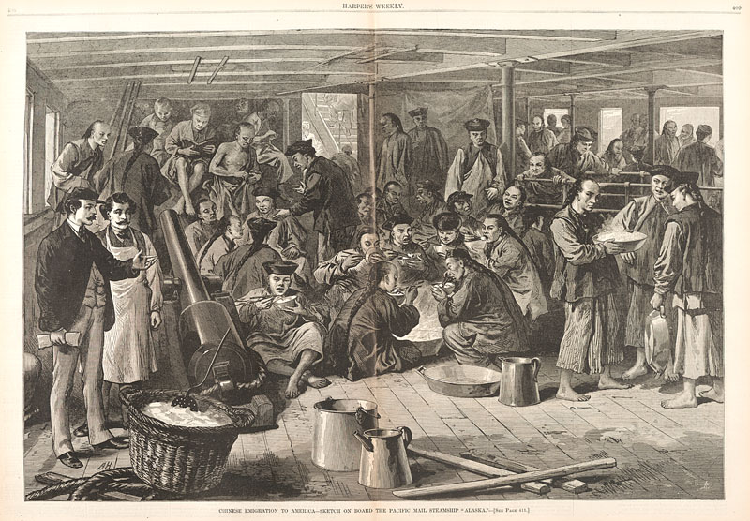
Engraving from Harper’s Weekly, May 20, 1876
Courtesy of Smithsonian Institution Libraries

Image B

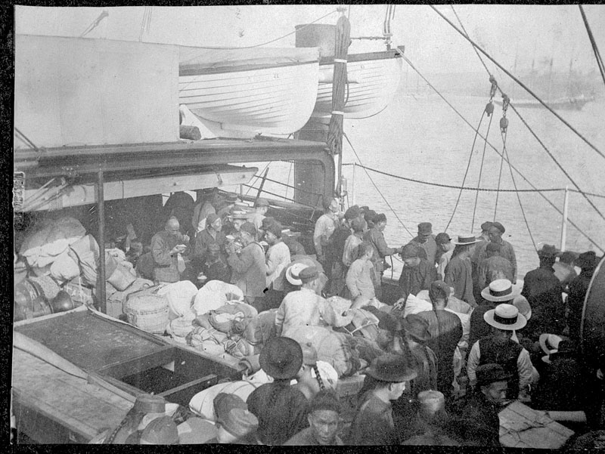

Chinese Passengers on Deck, 1900–15
Courtesy of the Hawaii State Archives

Image C

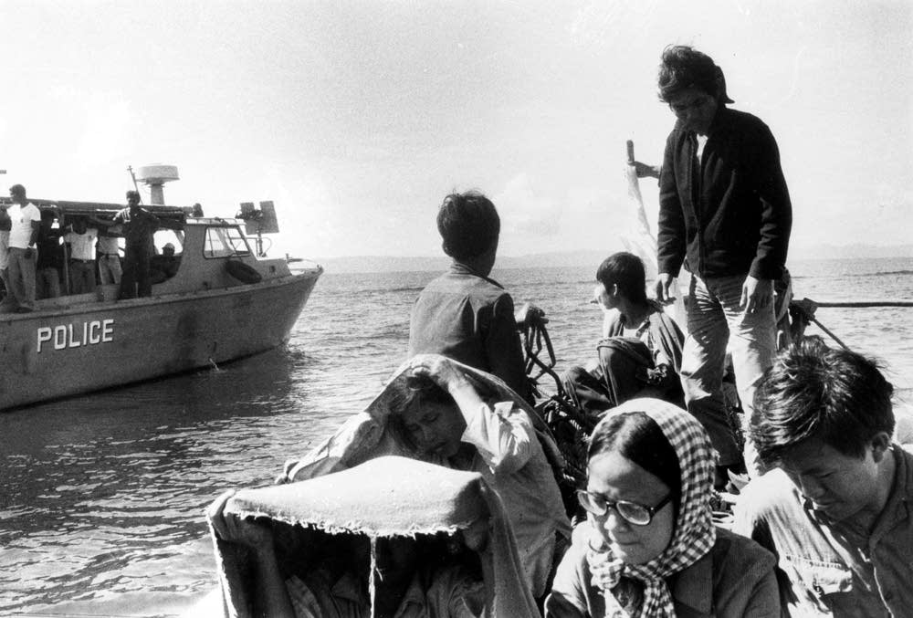
Eddie Adams |Associated Press

Image D
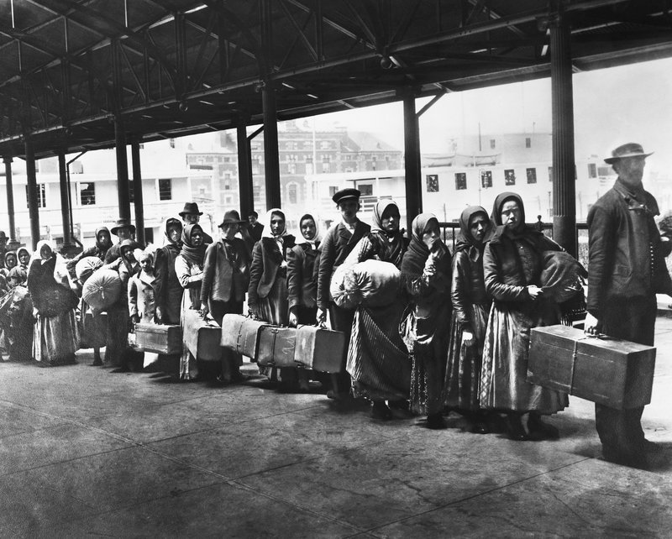
Immigrants on line leaving Ellis Island waiting for ferry to N.Y., ca 1900.
Bettmann / Getty Images
Image E

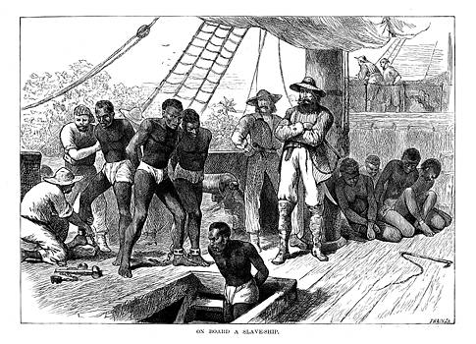
Captives being brought on board a slave ship on the West Coast of Africa (Slave Coast), c1880. Ann Ronan Pictures/Print Collector/Getty Images

Image F

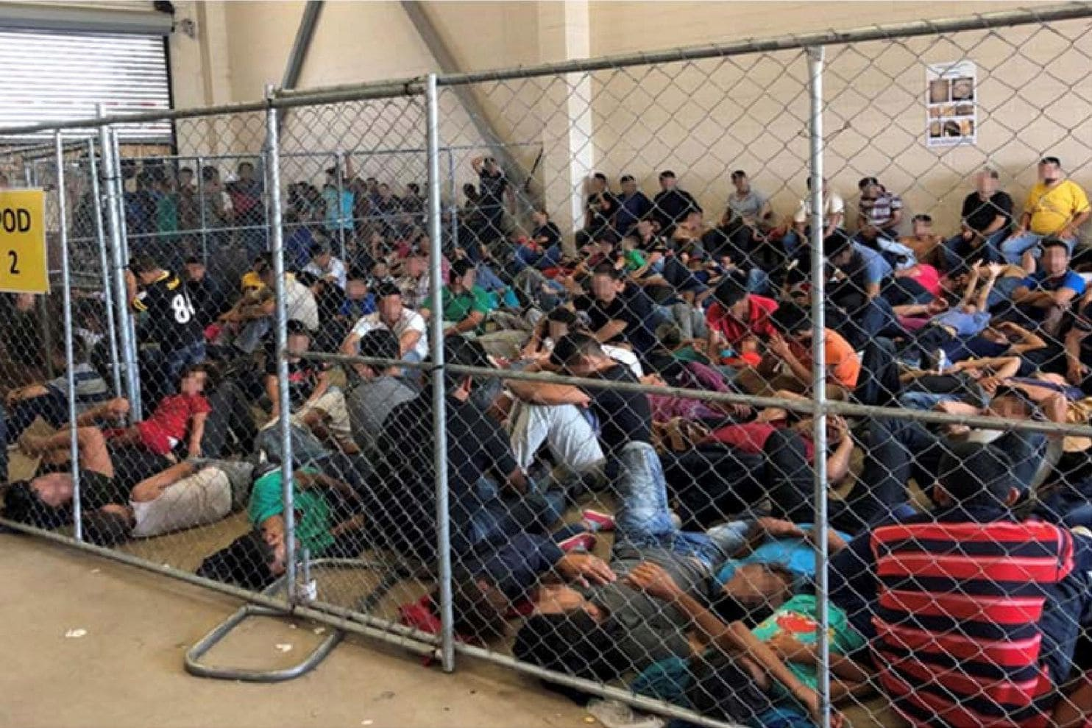
An overcrowded, fenced area holds families at a Border Patrol station in McAllen, Tex., on June 10. (Handout/Reuters)

Image G
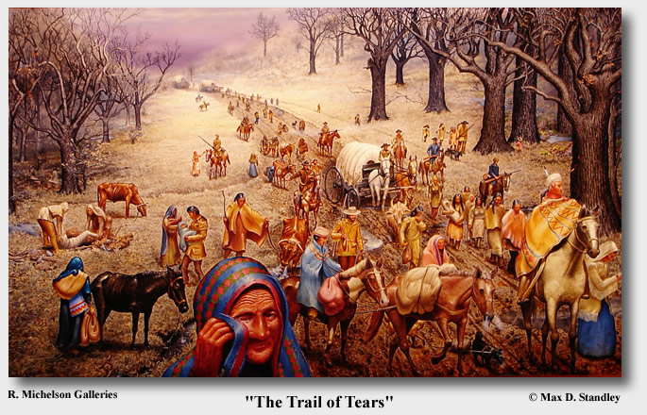

Image H

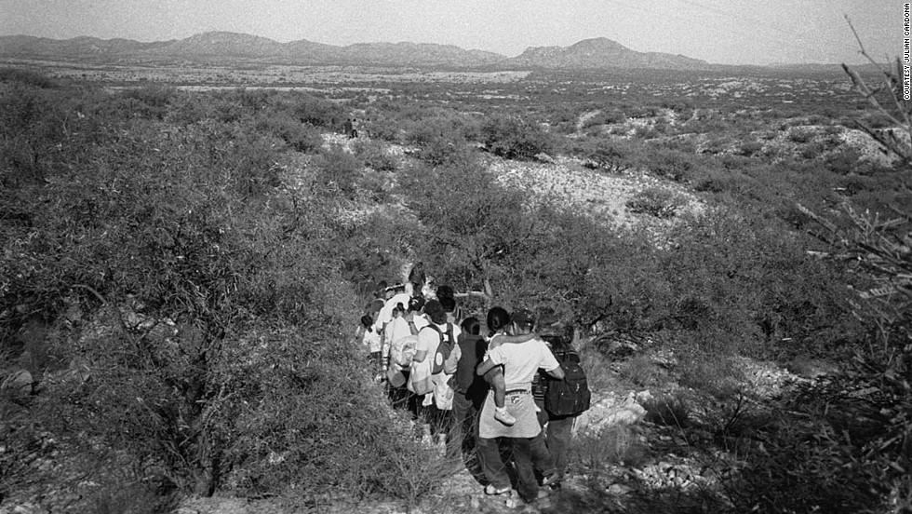
Julian Cardona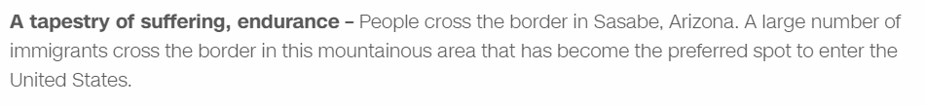

Image I

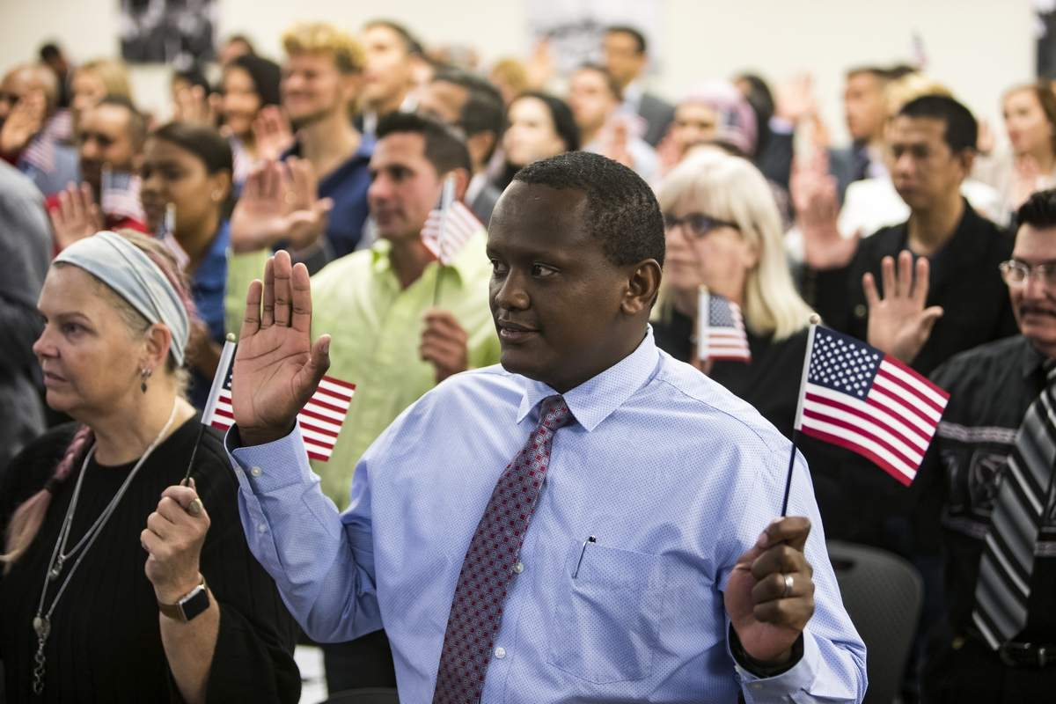

Patrick Ngubi, raises his right hand for the oath during a naturalization ceremony at the at the U.S. Citizenship and Immigration Services office in Tampa. Nearly 70 candidates received their citizenship in the ceremony. Ngubi is from Kenya, but has been here in the US for 17 years.MONICA HERNDON | Times

Name: ____________________________
See-Think-Wonder: We Came to America
Image ___ | I see … | I wonder … | I think ___ feels ___ because …
Example:  D | Example:  They are carrying suit cases.  No one is smiling. | Example:  Why do they have to wait in line? | Example:  I think they feel impatient because they’re waiting in line.

Name:______________________________
Reflection
What are some similarities you partner noticed between the images?
___________________________________________________________________________________________________________________________________________________________________________________________________________________________________________________

What are some differences you noticed between the images?
___________________________________________________________________________________________________________________________________________________________________________________________________________________________________________________

Pick one image. Compare and contrast the image to your family’s coming to America story.
I’m comparing and contrasting Image ___.

__________________________________________________________________________________________________________________________________________________________________

Image J COURTESY OF THE ROYAL BC MUSEUM Image K
Poster announcing the democratic passage
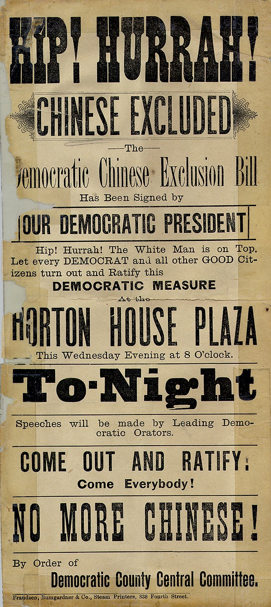
of the Chinese Exclusion Act. Protestors outside Boston State House, 2017, IN response to Texas governor Rick Perry’s agreement to house 1,000 undocumented immigrant children Justin Sullivan/Getty
