America is…
9-12 Lesson Plan
Heather Lurvey, Micah Richardson, Andrew Ahn

Opening Prompt: Complete the phrase “America is…”
- Think about…
  - What is the primary story/popular narrative that you’ve heard about America?
  - What have you been told about America?
  - What have you been told about America that you no longer believe?

Share (and record student responses on chart paper)

Guided Practice Activity:
- Look at the image and use the following Parts/People/Interactions questions to analyze the image.
  - What are the parts? What do they do?
  - Who are the people? What do they do?
  - How do the parts and people work together? What would happen if a part (or a person) were missing or changed?
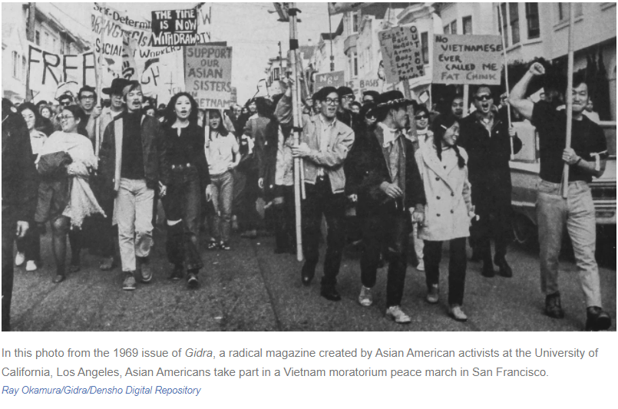
- Reflection:
  - How does this image connect to, extend, or challenge what was shared in the opening prompt about America?
  - How does this push your own thinking about America and what it means to be American?
Small Group Activity:
- Students will be broken into groups of 3-4. Each group will rotate between stations, with each station containing one of the sources below. (Note: teachers may select some or all of the sources from the list below)
- At each station, students will work together to apply the Parts/People/Interactions analysis method to each source.
- Students should record their answers using the chart found here.
Source Options for Stations:
- Langston Hughes “I, Too” https://www.poetryfoundation.org/poems/47558/i-too
- Carlos Bulosan’s “I Want the Wide American Earth” https://digitalcollections.lib.washington.edu/digital/collection/pioneerlife/id/26238/
- Lum May testimony (Tacoma Expulsion) https://www.washingtonhistory.org/wp-content/uploads/2020/04/lumMayStatement.pdf
- Korematsu testimony (pg. 9 of PDF) https://resources.billofrightsinstitute.org/wp-content/uploads/2014/12/SCDBQ-029-HandoutB.pdf
- Executive Order 9066 (Text + Image of soldier posting Civilian Exclusion Order No. 1) https://www.ourdocuments.gov/doc.php?flash=false&doc=74&page=transcript & https://digitalcollections.sjsu.edu/islandora/object/islandora%3A62_162
- Korematsu Video Clip: https://youtu.be/2tCDvCwOSCg
- Define American Project https://www.defineamerican.com/stories/view
- Tape v. Hurley https://americanhistory.si.edu/brown/history/2-battleground/detail/tape-family.html
- Separate is Never Equal by Duncan Tonatiuh (picture book) https://socialjusticebooks.org/separate-never-equal-sylvia-mendez-familys-fight-desegregation/
- Art of Mine Okubo https://janm.emuseum.com/groups/mine-okubo-collection/results
- Emma Lazarus “The New Colossus” https://www.poetryfoundation.org/poems/46550/the-new-colossus
- Childish Gambino “This is America” https://genius.com/Childish-gambino-this-is-america-lyrics
- Carlos Bulosan excerpt from America is in the Heart https://advancingjustice-la.org/sites/default/files/ESUSHELAPVC%20America_Is_in_the_Heart_Excerpt.pdf
- Wing Luke collaboration with Tenement Museum: https://yourstory.tenement.org/
- Gaman art: https://americanart.si.edu/exhibitions/gaman & https://www.npr.org/templates/story/story.php?storyId=126557553

Debrief
- What two sources resonated with you most?
- In terms of content, style, type of source, how do these two sources together enhance your understanding about America and what it means to be American? Consider similarities and differences

Independent Work:
- After the group activity, students will work independently to create a product that explores the question: What does it mean to be American?
- Students can propose different types of products (choices can include essay, poem, visual art, podcast/recording, song, annotated playlist…)

